USER MANUAL FOR MEETING COORDINATOR

The coordinator will first be prompted to sign in with credentials.

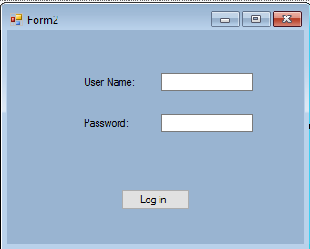

After the coordinator signs in they would be shown the first form with the already existing info that the coordinator received from individuals.

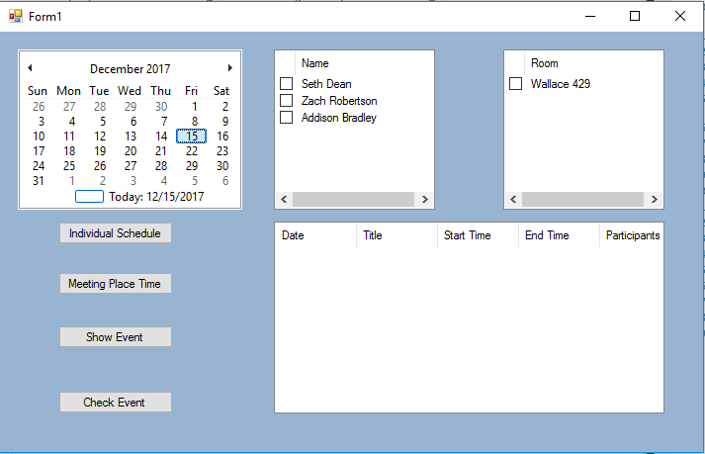

If the user wanted to check the times available for each person and room, each person can be checked and the room can be checked.

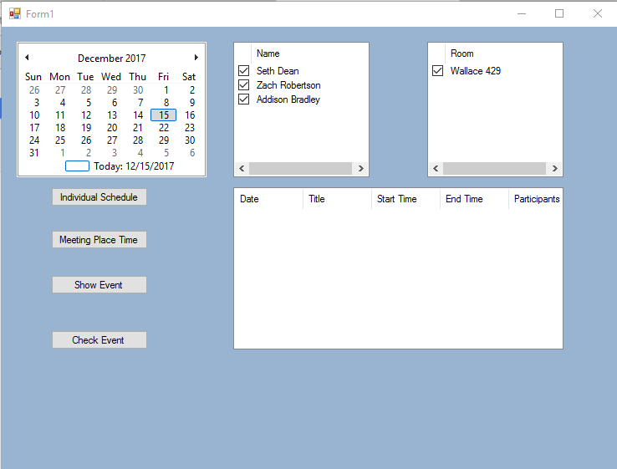

After each person and room is checked, “Check Event” can be clicked on. Then the people with checked and rooms that are checked will show times available for events.

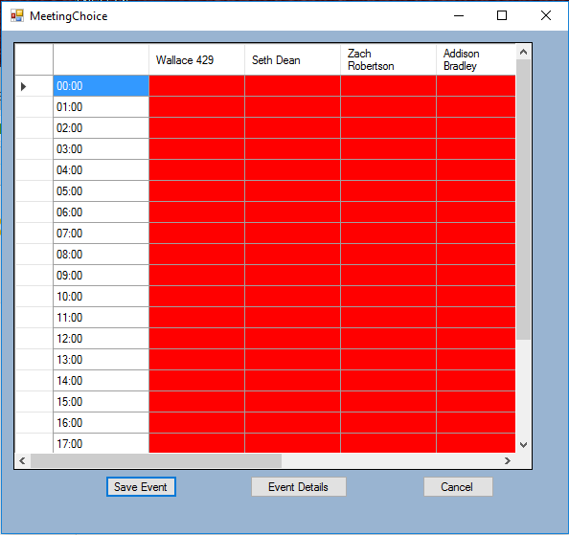

If the coordinator wanted to change the schedule for an individual person, the one person can be checked and “Individual Schedule” can be clicked to open.

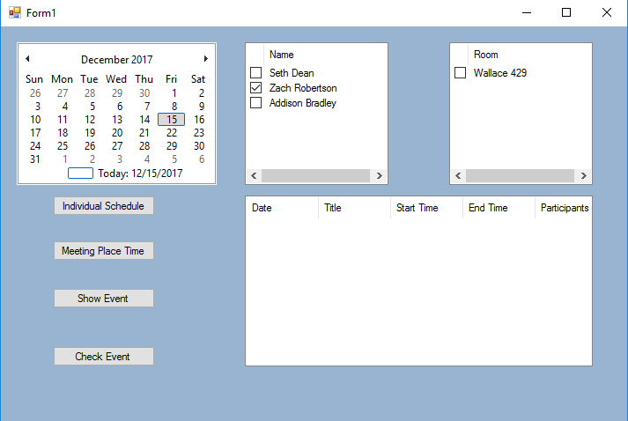

(After Individual Schedule is clicked)

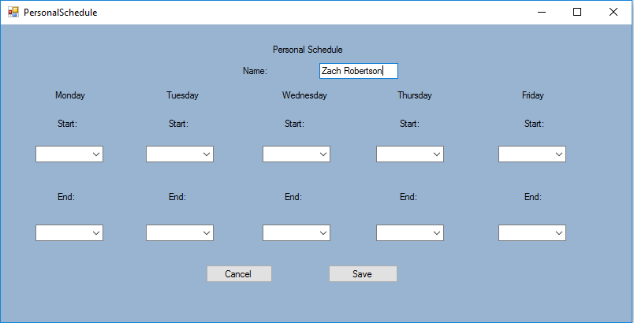

Coordinator will then be able to change the times as needed.

If the coordinator wanted to add another person to the available people. The coordinator will be able to click on Individual Schedule with no people checked, and type the person’s name and times available.

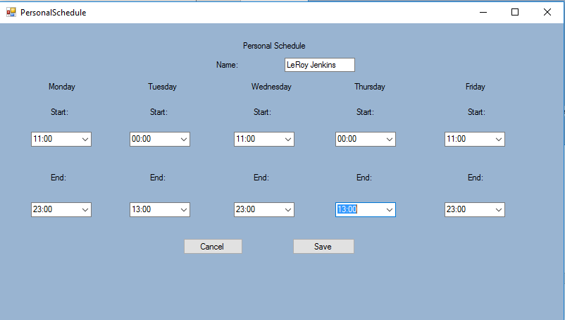

After coordinator clicked “Save” the person and their times will now be saved and they can now be clicked on in the first page.

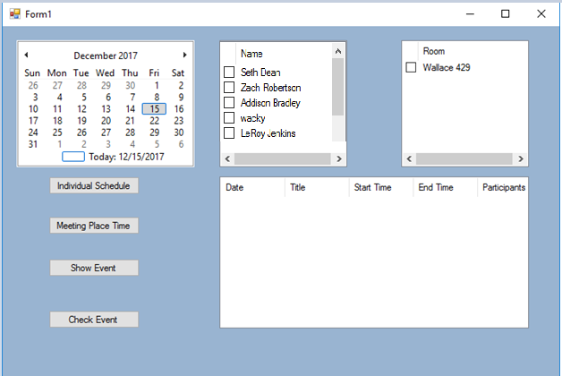

If the coordinator wanted to change the meeting times, the coordinator would be able to have the meeting room checked, and “Meeting Place Time” can be clicked”

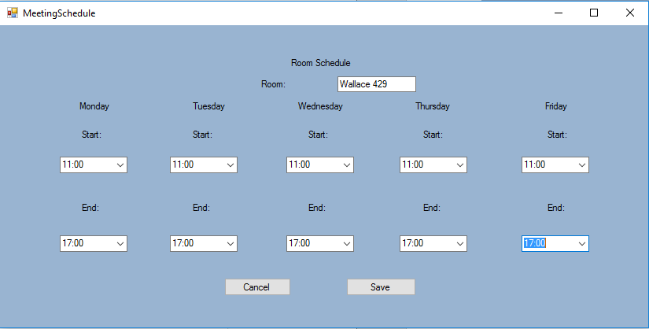

Once the coordinator clicks save, the changes and times would be added to the first form.



The coordinator would also have the option to adding a new meeting place. By clicking on “Meeting Place Time” with nothing checked, the coordinator would be able to add the name and times of the new meeting place.

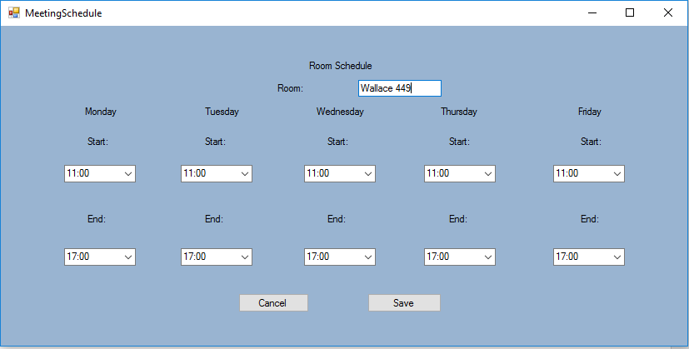

Once clicked on “Save” the meeting place and times would be saved on the first form.

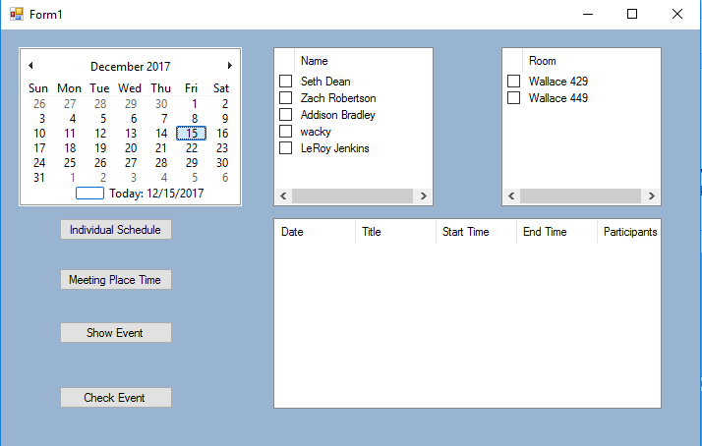

After all times for people and places are added, the “Check Event” can be clicked and the new times and places will show available event times.



At the bottom of the page the coordinator would have more options.

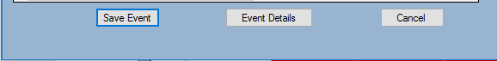

The coordinator at this point in time would be able to “Save Event”, see “Event Details” or Cancel.

The coordinator would be able to pick a time that shows available for all people and meeting place, and once times has been selected the event would be added to the first page with the event showing on the bottom corner.

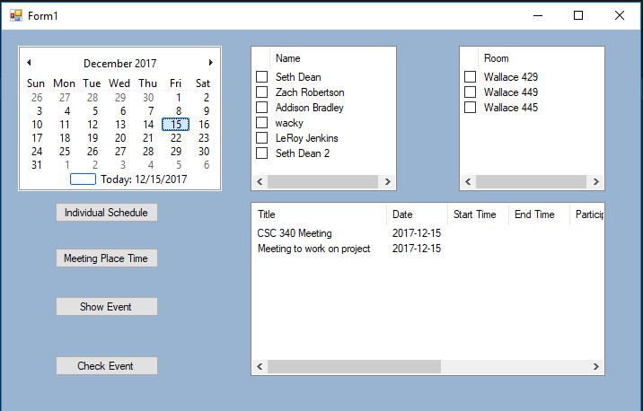

(this would be for event details on the meeting chosen)

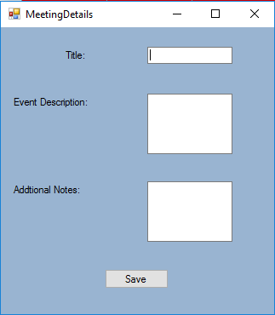

(this is the Check Event Window, blank for right now)

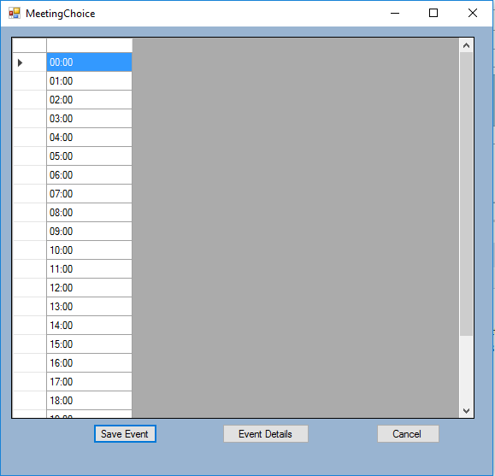

When you select an event in the main view you are then able to see the details of the chosen event

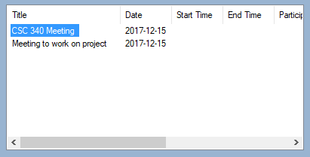

Hit the show event button on the left-hand side and it will bring up the details for that event



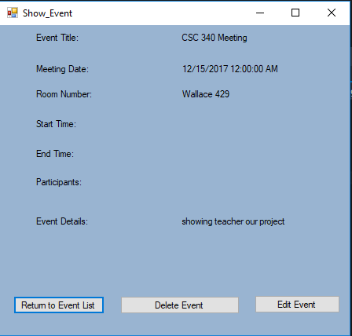

Within this view, you are given the option to return to the event list (which is the one that you were previously at), delete the event that we have chosen, or edit the event.

When the delete event option is chosen, a new window will appear with the options of clicking “yes” to delete the event or “no” to just return to the show event view

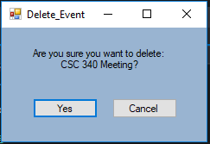

Click yes will update the view to the main view as well as updating the listings within the event.

